**Project 2**

**John Hopkins University**

**Kai M. Hall**

**November 14, 2020**

**Topic:** Car Crashes in the Montgomery County

**Data Sets:**

Crash Report Incident Data (https://data.montgomerycountymd.gov/Public-Safety/Crash-Reporting-Incidents-Data/bhju-22kf/data)

This dataset provides general information about each collision and details of all traffic collisions occurring on county and local roadways within Montgomery County, as collected via the Automated Crash Reporting System (ACRS) of the Maryland State Police, and reported by the Montgomery County Police, Gaithersburg Police, Rockville Police, or the Maryland-National Capital Park Police.

Please note that these collision reports are based on preliminary information supplied to the Police Department by the reporting parties. Therefore, the collision data available on this web page may reflect

**Meta-data screenshot:**

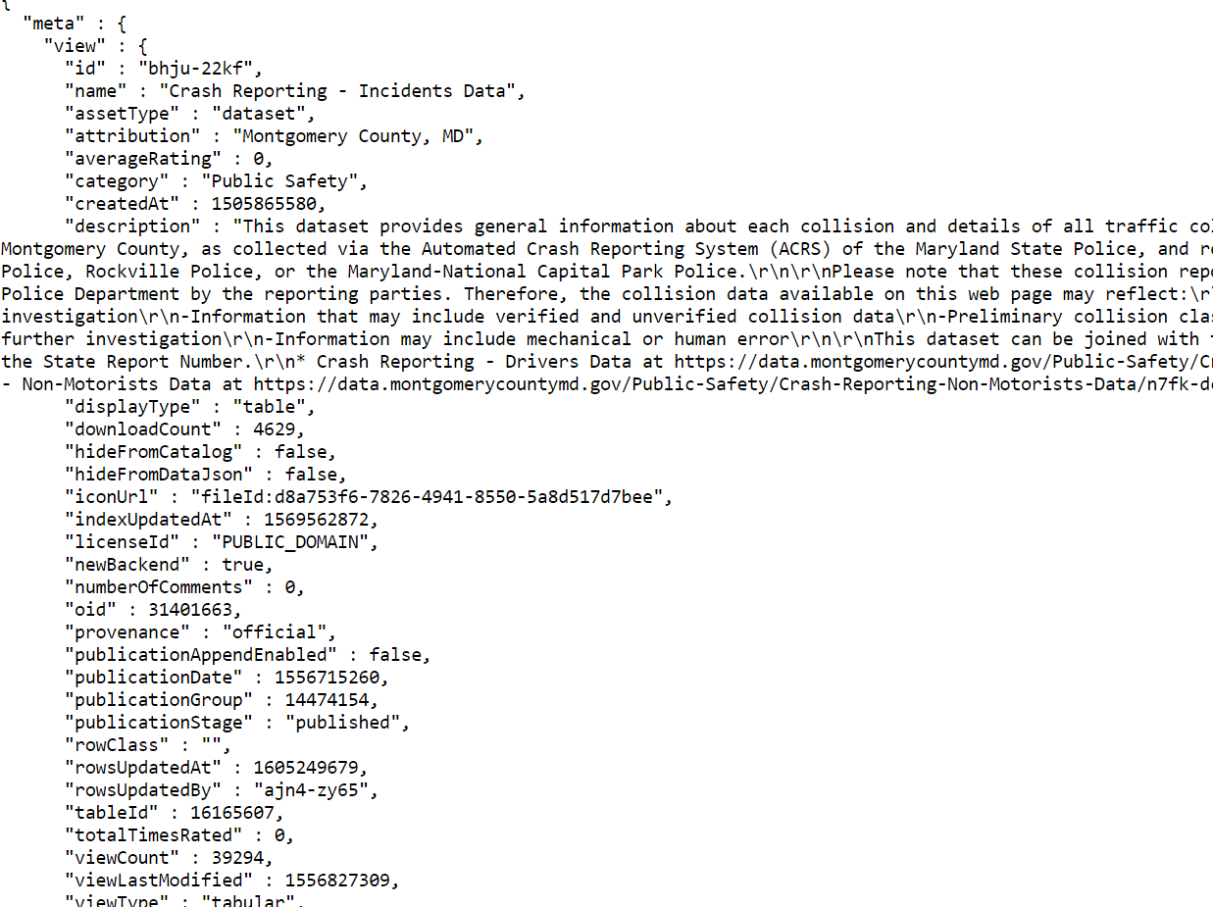

**Inspiration:**

I’ve been driving in the DMI for fifteen years. I’ve seen many car crashes, some that have ended tragically. This project hopes to visualize the frequency of car crashes with specific details shown: the location, if alcohol was present, and damage over year 2020 thus far. The hope is to persuade the push for self-driving cars.

**Inspiring Visualizations:**

This visual will show the specific locations and number of crashes.

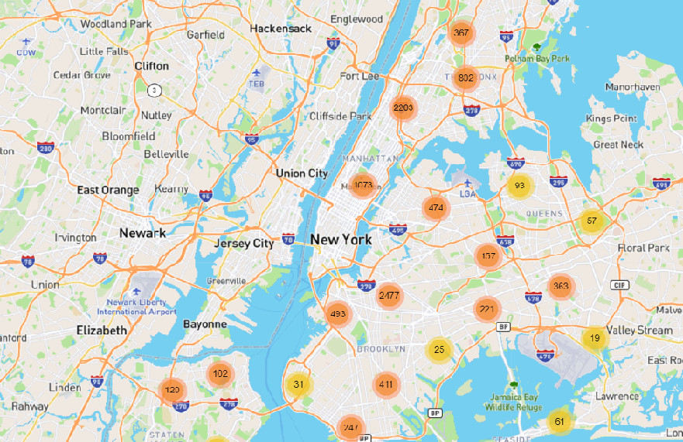

This visual will show the police departments and the size of the bubble will be number of crashes reported.

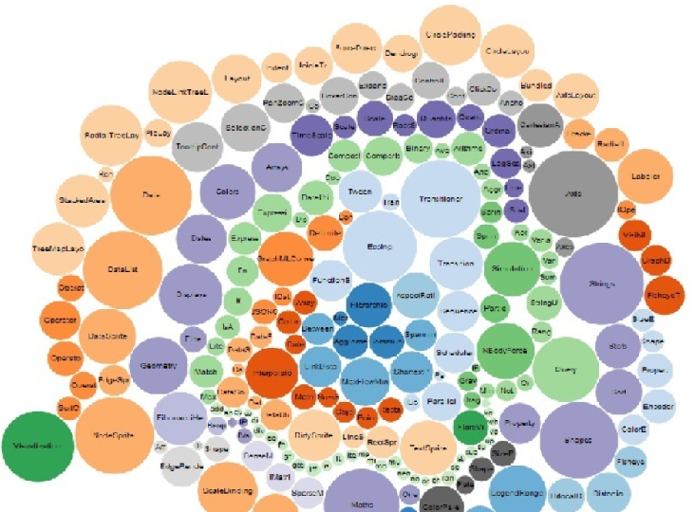

1. Your visualization must include a Python Flask–powered API, HTML/CSS, JavaScript, and at least one database (SQL, MongoDB, SQLite, etc.).
2. Your project should fall into one of the below four tracks:
   * A custom “creative” D3.js project (i.e., a nonstandard graph or chart)
   * A combination of web scraping and Leaflet or Plotly
   * A dashboard page with multiple charts that update from the same data
   * A “thick” server that performs multiple manipulations on data in a database prior to visualization (**must be approved**)
3. Your project should include at least one JS library that we did not cover.
4. Your project must be powered by a data set with at least 100 records.
5. Your project must include some level of user-driven interaction (e.g., menus, dropdowns, textboxes).
6. Your final visualization should ideally include at least three views.